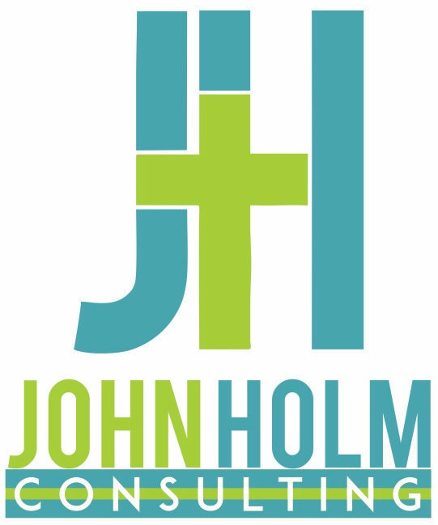
John Holm Consulting, LLC
1660 N. Prospect Ave., Unit 2211
Milwaukee, WI 53202 john@johnholmconsulting.com
847-800-5513

Invoice for Consulting Services Lutheran Church of the Resurrection, Racine, WI

Invoice #: LCR020423

Date: 02/04/2023

Combined Ministry Review & Organizational Development Mtg $750.00
Total Invoice $750.00

Please make check payable to: John Holm Consulting, LLC

Due within 30 Days of receipt.

